Name: Sally Oketch

Email: [sally.oketch@womentechsters.org](mailto:sally.oketch@womentechsters.org)

1. **Deploy a windows server 2016 Gen 1 remotely on your machine from Azure**

**cloud.**

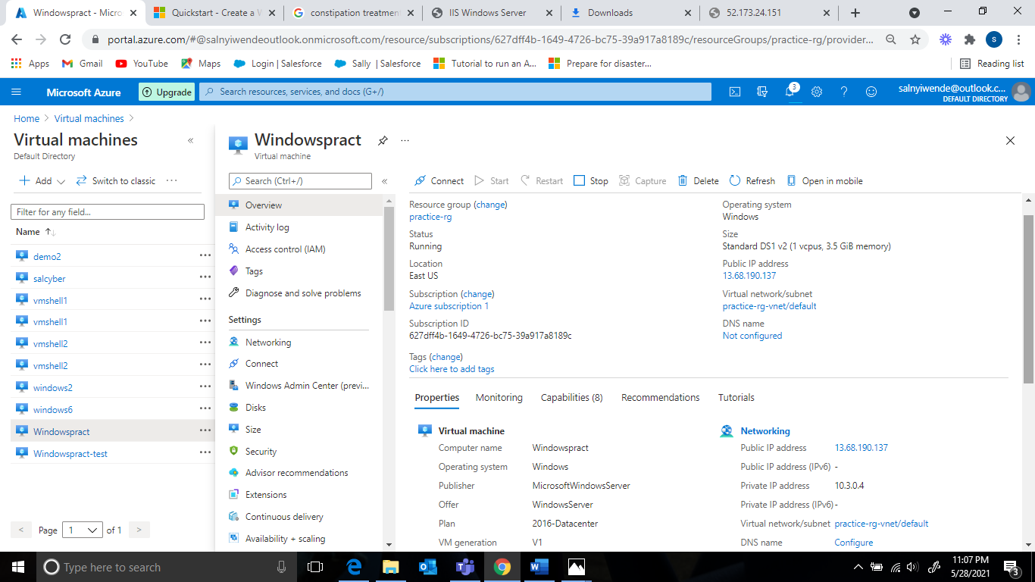

1. **Install the windows feature- Web server management tools and confirm from your browser.**

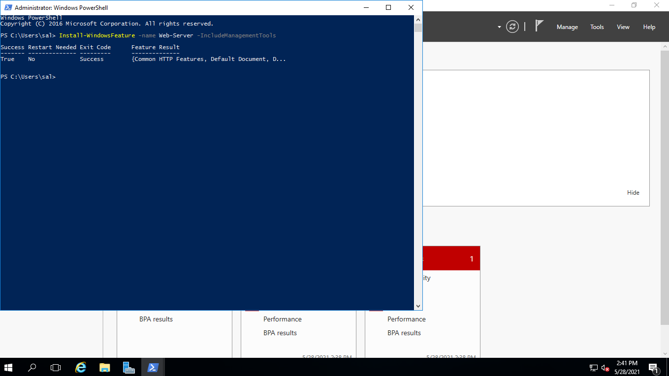

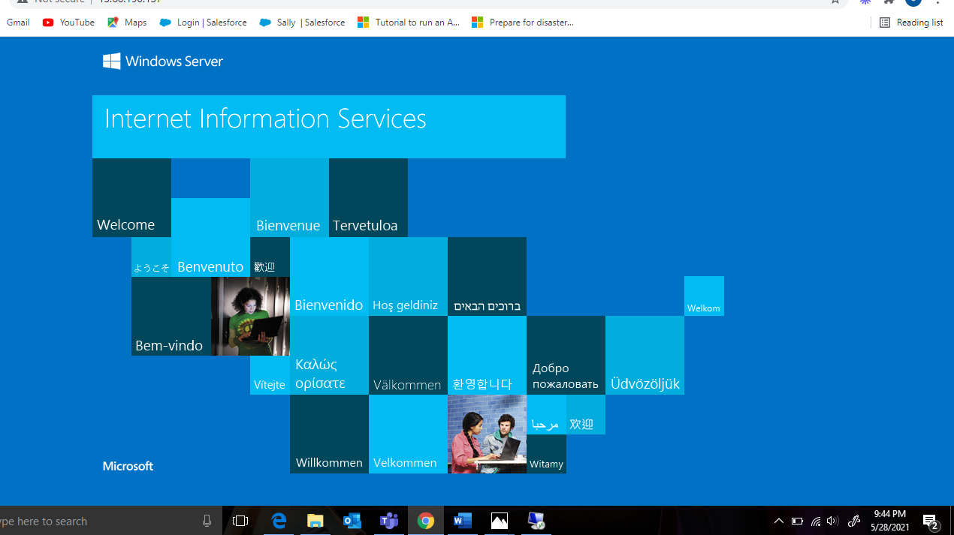

1. **Create a Site Recovery Service Vault. Since your site will contain only one Windows Server just add the Windows server to Replicated Items in the Recovery Service Vault to be tracked.**

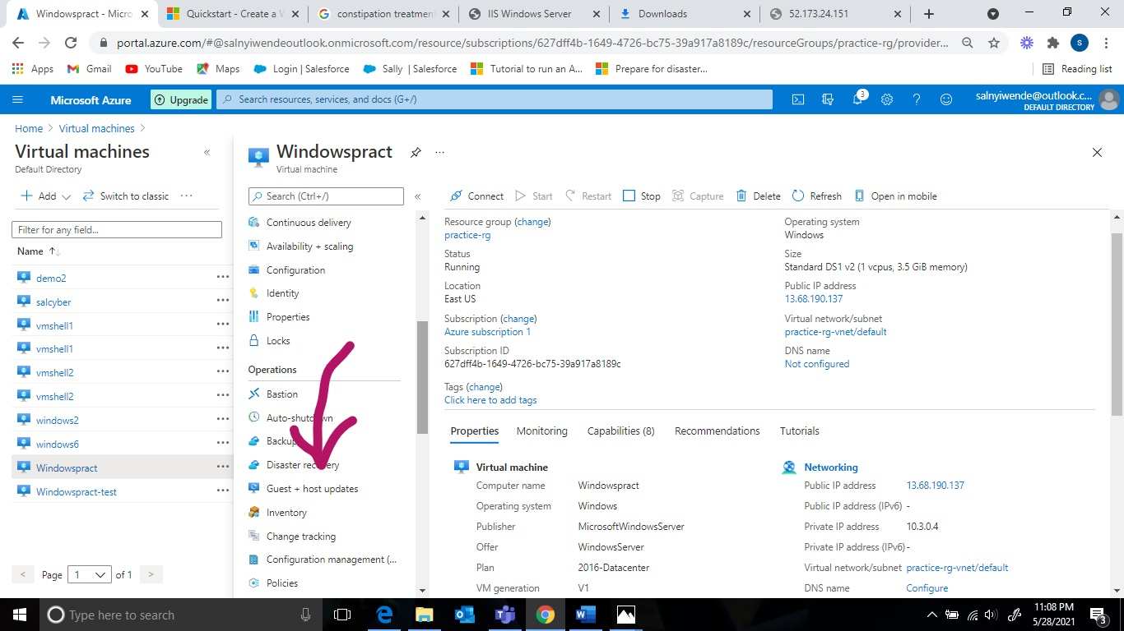

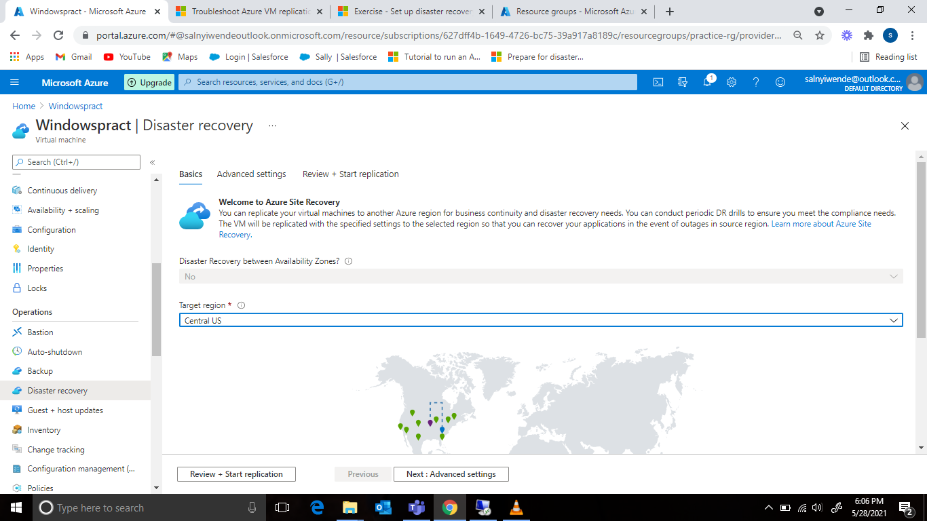

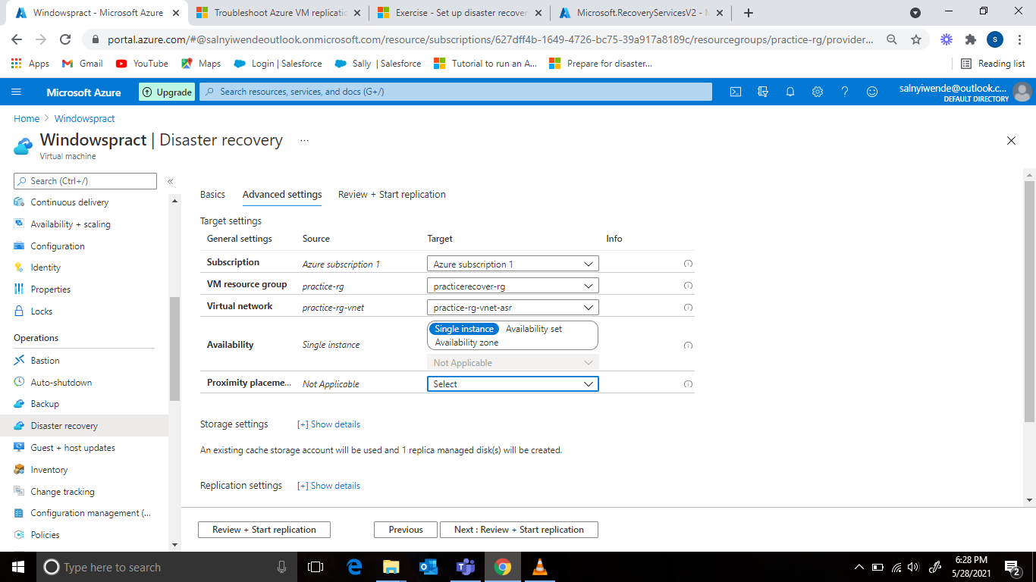

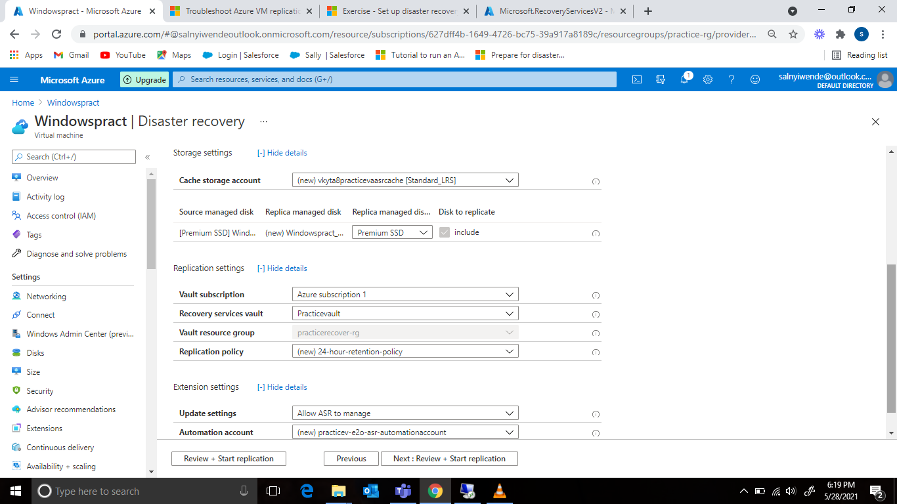

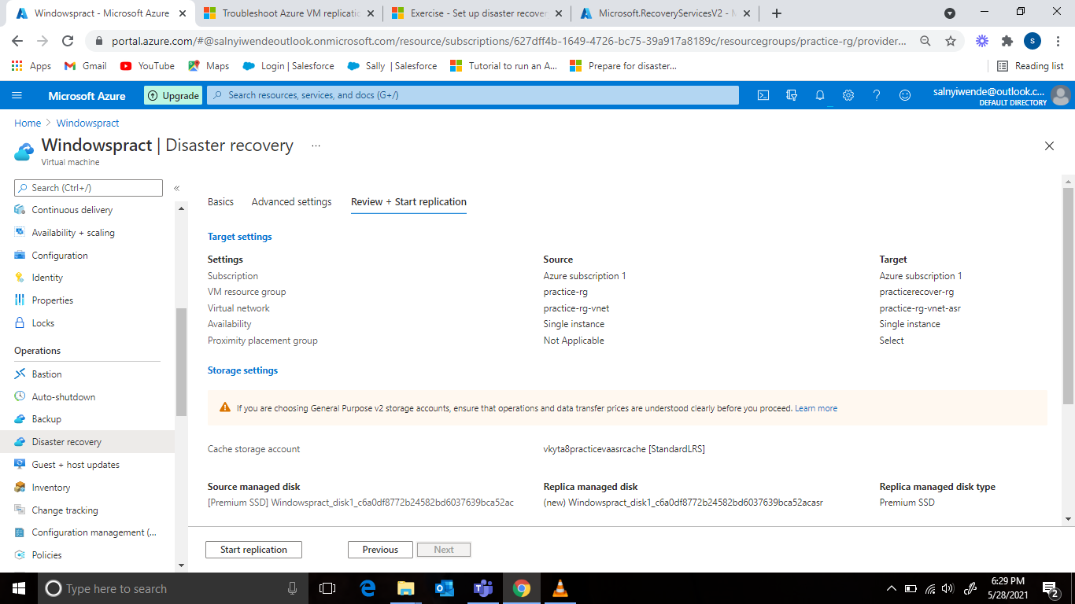

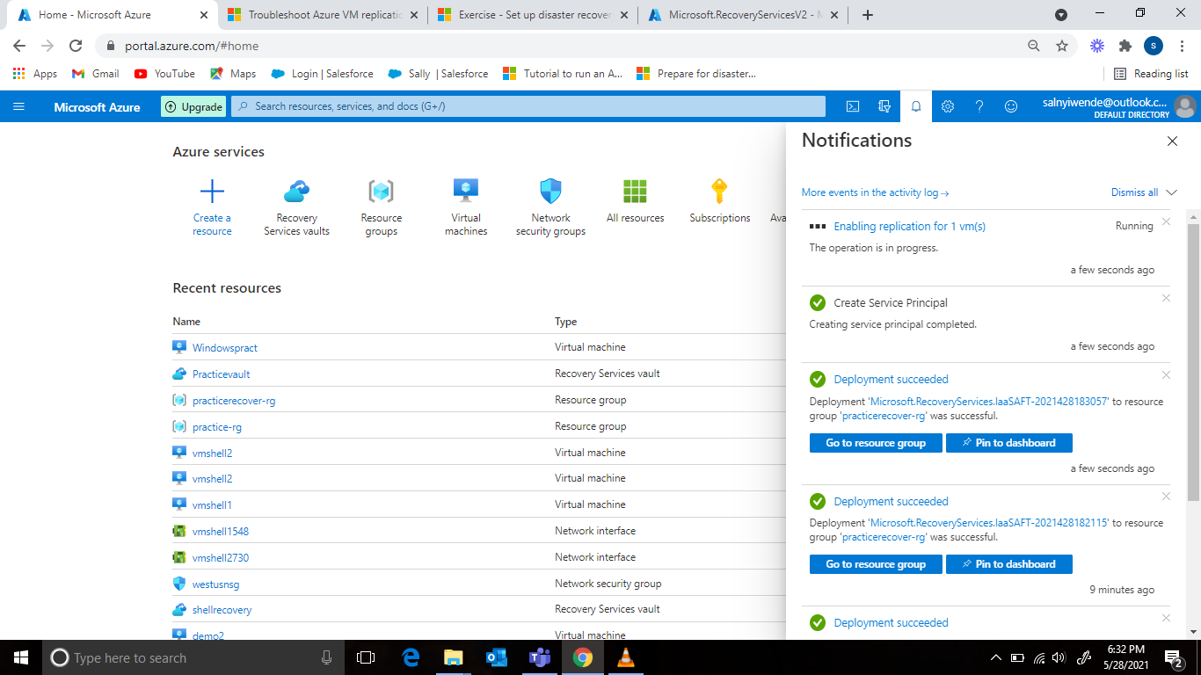

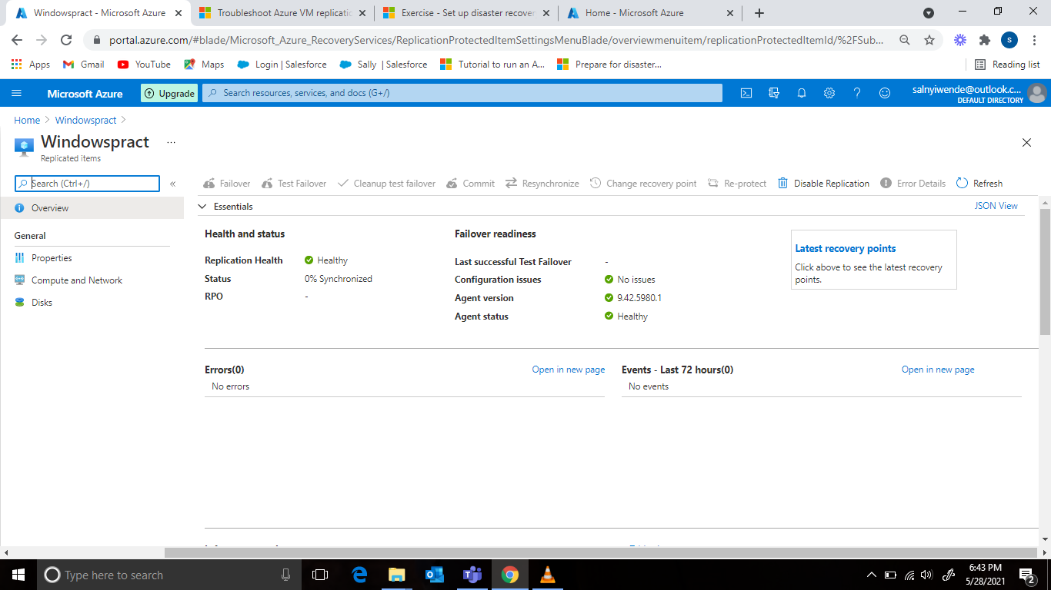

**Wait until the status is changed from 0% to protected**

1. **Stop the Windows server from Azure to Assume it’s ‘breakdown’**

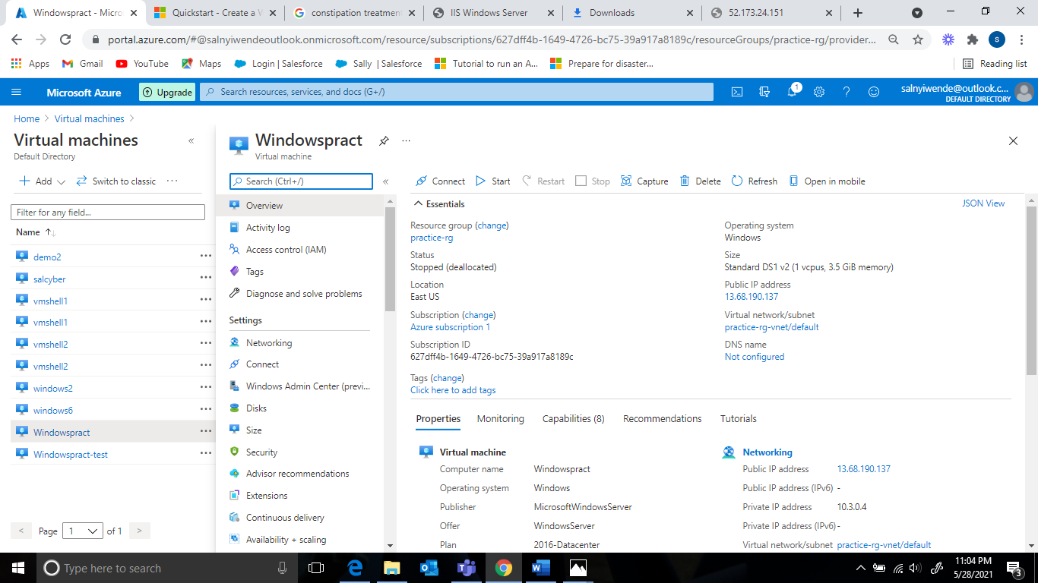

1. **Then perform a Test Failover for the windows server.**

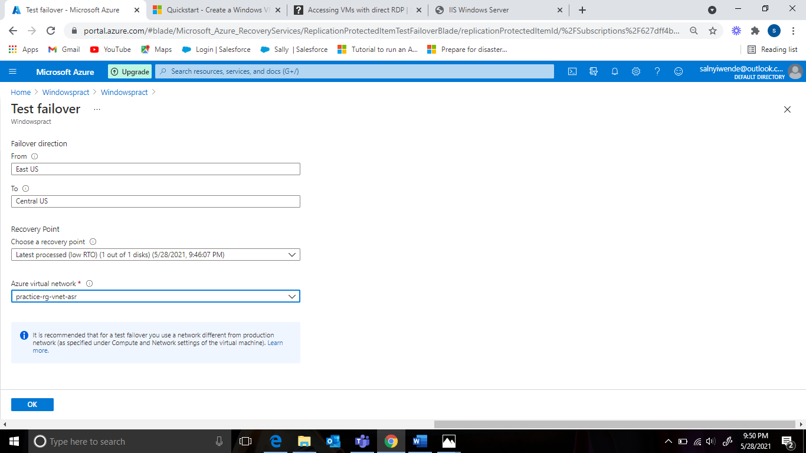

1. **The test failover process should start.**

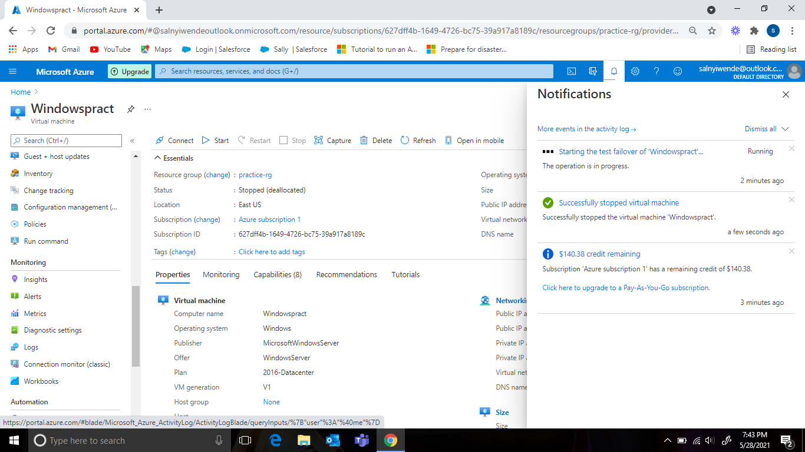

1. **You should see a replicated copy of the windows server and run it, copy the public IP address and test it from your browser.**

